Milestone # 1

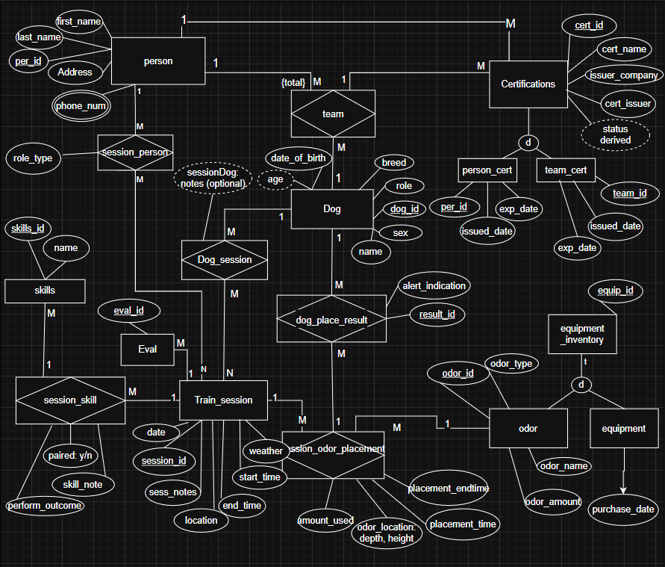
EER Model

UML Model
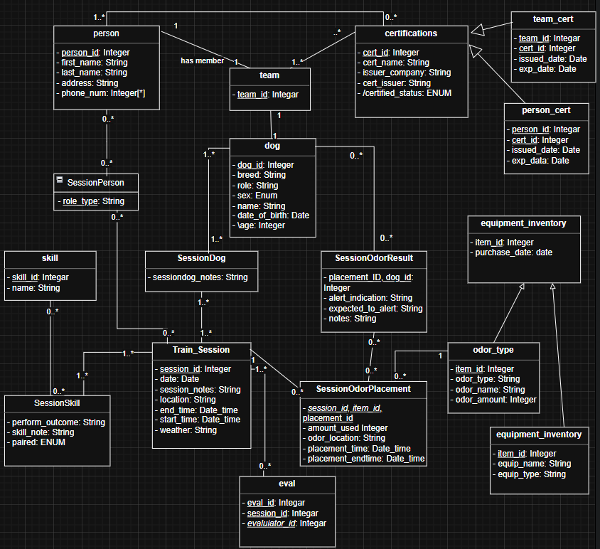

Logical Relational Model

Strong Entities:
R1 DOG (dog_id, name NOT NULL, breed NULL, date_of_birth NOT NULL, \age NULL, sex, role NULL)
- PK: dog_id
R2 PERSON (person_id, first_name NOT NULL, last_name NOT NULL, phone_num NULL, address NOT NULL, role_type NOT NULL, experience NOT NULL)
- PK: person_id
R3 TRAIN_SESSION (session_id, date NOT NULL, session_notes NOT NULL, location NOT NULL, start_time NOT NULL, end_time NOT NULL, weather NULL)
- PK: session_id
R4 SKILL (skill_id, skill_name NOT NULL UNIQUE)
- PK: skill_id
R5 CERTIFICATIONS (cert_id, cert_name NOT NULL, issuer_company NOT NULL, cert_issuer NOT NULL, \certified_status NULL)
- PK: cert_id
- \certified_status derived (based on expiration)

Supertype/ subtype for ODOR and Equipment:
R6 EQUIPMENT_INVENTORY (item_id, purchase_date NOT NULL)
- PK, FK: item_id referring to EQUIPMENT_INVENTORY(item_id)
R7 EQUIPMENT (item_id, equip_name NOT NULL, equip_type NULL)
- PK, FK: item_id referring to EQUIPMENT_INVENTORY(item_id)
R8 ODOR_TYPE (item_id, odor_type NOT NULL, odor_name NOT NULL, odor_amount NULL,)
Teams + Certifications:
R9 TEAM (team_id, dog_id NOT NULL, person_id NOT NULL)
- PK (team_id, dog_id, person_id)
- FK (person_id) referring to PERSON NOT NULL
- FK (dog_id) referring to DOG NOT NULL
R10 PERSON_CERT (person_id, cert_id, issued_date NOT NULL, expired_date NOT NULL, \certified_status NULL)
- PK: (person_id, cert_id, issued_date)
- FK: cert_id referring to CERTIFICATIONS (cert_id) NOT NULL
- FK: person_id referring to PERSON (person_id) NOT NULL
R11 TEAM_CERT (team_id, cert_id, issued_date NOT NULL, expired_date NOT NULL, \certified_status NULL)
- PK: (team_id, cert_id, issued_date)
- FK: cert_id referring to CERTIFICATIONS (cert_id) NOT NULL
- FK: team_id referring to TEAM (cert_id) NOT NULL
Evaluations (Before a certifying certification, tied to Session):
R12 EVAL (eval_id, session_id UNIQUE, evalutor_id result NOT NULL)
- PK: (eval_id)
- FK: evalutor_id referring to PERSON (person_id) NOT NULL
- FK: session_id referring to TRAIN_SESSION (session_id) NOT NULL
Associative Tables:
R13 SESSION_DOG (dog_id, session_id, sessiondog_notes NULL)
- PK: (dog_id, session_id)
- FK: dog_id referring to DOG (dog_id) NOT NULL
- FK: session_id referring to TRAIN_SESSION (session_id) NOT NULL
R14 SESSION_PERSON (session_id, person_id, session_role NOT NULL)
- PK: (session_id, person_id)
- FK: session_id referring to TRAIN_SESSION (session_id) NOT NULL
- FK: person_id referring to PERSON (person_id) NOT NULL
R15 SESSION_SKILL (session_id, skill_id, perform_outcome NOT NULL, skill_note NULL, paired NULL)
- PK: (session_id, skill_id)
- FK: session_id referring to TRAIN_SESSION (session_id) NOT NULL
- FK: skill_id referring to SKILL(skill_id)
Training Session with Session Odor Placement + Dog Session Result:
R16 SESSION_ODOR_PLACEMENT (placement_id, session_id NOT NULL, item_id NOT NULL, amount_used NULL, hide_location NULL, placement_time NULL, placement_endtime NULL)
- PK: (placement_id)
- FK: session_id referring to TRAIN_SESSION (session_id) NOT NULL
- FK: item_id referring to ODOR_TYPE (item_id) NOT NULL
R17 SESSION_ODOR_RESULT (placement_id, dog_id, alert_indication NOT NULL, expected_to_alert NOT NULL, notes NULL)
- PK: (dog_id, placement_id)
- FK: placement_id referring to SESSION_ODOR_PLACEMENT (placement_id) NOT NULL
- FK: dog_id referring to DOG(dog_id) NOT NULL

Constraints and Assumptions:
Enforceable in the relational schema (PK/FK/UNIQUE)
- Foreign keys enfore referential integrity—SESSION_DOG rows must reference existing DOG and TRAIN_SESSION rows).
- Many-to-Many relationships is using associative relations (SESSION_DOG, SESSION_PERSON, SESSION_SKILL, SESSION_ODOR_RESULT.
Business Rules not enforceable with PK/FK/NULL—Requires logic/triggers
- Minimum participation rule – each session must have at least 1 dog.
- Every dog must have at least 1 evalution/assesment in its history within a certain period.
- Each odor placement must have a result row per dog in session.
- Specialization constraint—EQUIPMENT_INVENTORY is total and disjoint. It is ODOR or EQUIPMENT, cannot be both.
- Certification policy – a team (handler + dog) must be certified to deploy.
Normalization:
This model is normalized to 3NF. Any repeating groups and multi-valued attibutes are decompressed into associative realtions (SESSION_DOG, SESSION_PERSON, SESSION_SKILL, SESSION_ODOR_RESULT), ensuring no duplication and update irregularities. References or type data (CERTIFICATIONS, SKILL, and the ODOR/EQUIPMENT subtype tables) is separated from event data (TRAIN_SESSION, SESSION_ODOR_PLACEMENT, and results), ensuring non-key attributes depend on the key and only the key. The derived values (/age and /certified_status) are computed and not stored.
Future Expansion:
To support odor lifecycle management (age, degradation, number of uses, or hours of use), this model could be expanded to ODOR_LOT entity (purchase_date, quantity, expiration, degradation meta data) and a foreign key from SESSION_ODOR_PLACEMENT to ODOR_LOT. An attribute type repurchase_needed would be derived based on age, hours, and usage counts according to the products information.

AI Use:
I created the Milestone #1 EER/UML model, and logical relational model. I used OpenAI ChatGPT as an editing and review tool to clairfy steps and concepts, check for consistency across the models (keys, attributes, cardinalities), and improve wording formatting for clairity. This final product reflects my understanding and judgment.
AI Assisted section include: Constraints and assumptions (verification and revision), the normization paragraph, and relational model formatting.

References:
Lemahieu, W., Vanden Broucke, S., & Baesens, B. (2018). Principles of database management: The practical guide to storing, managing and analyzing big and small data. Cambridge University Press.
OpenAI. (2026, February). ChatGPT (GPT-5.2 Thinking) [Large Language Model]

